i.POCUS.ED

Introduction to Point of Care Ultrasound in the Emergency Department

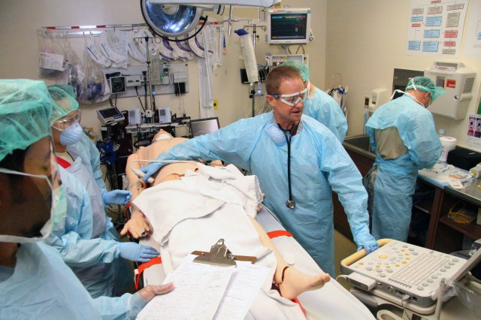

Time Table

Four main ultrasound modules covered:
- AAA (3 hours)
- Lung (2 hours)
- FELS (6 hours)
- EFAST (3 hours)
This course is accredited with ASUM and ACEM for 14 hours of CPD

Day 1

08:00 – 08:30 am registration

08:30 – 11:30 am AAA module: 1 hour presentation then 2 hours of real - life scanning time with volunteers

11:30am – 11:45am Morning Tea

11:45 – 13:45 pm Lung module: 1 hour presentation then 2 hour of real – life scanning time with volunteers

13:45 – 14:15 pm Lunch

14:15 – 17:15 pm first half of FELS module: 1 hour presentation then 2 hours of real – life scanning on volunteers

17:15 -17:30 pm: round up of the day, questions, comments and close.

Day 2

09:00 – 09:30 am registration, questions to faculty from previous day.

09:30 – 12:30 am completion of FELS module

12:30 – 13:00 pm Lunch

13:00 – 16:00 pm EFAST module: 1 hour presentation and 2 hours of real-life scanning on volunteers

16:00-16:15 pm Afternoon Tea and any questions to faculty

16:15 – 17:15 pm Assessment MCQ’s

17:15 – 17:30 pm Completion of evaluation forms and conclusions and summary for the 2 days.

Course Instructors

- Dr Christopher Tang, FACEM, CCPU at Redlands Hospital, (Course Director)
- Dr Zeena Tawfik, FACEM, CCPU at Albury Wodonga Health
- Dr Audrey Vignisdottir, CCPU, Senior ED Registrar at Logan Hospital, Brisbane.
- Dr Matthew Morris, Senior ED Registrar at Redlands Hospital, Brisbane.
- Dr Jian Lee, FACEM, CCPU at Redlands Hospital
- Dr Sudath Weerapperuma, FACEM, CCPU at The Mater Hospital, South Brisbane

i.POCUS.ED – Introduction to Point of Care Ultrasound in the Emergency Department

Welcome!!

This course is to give you the basics to be able to perform a scan in the emergency setting and to be able to interpret the images you get. Both are important.

By now you should have completed the online modules in PHYSICS, AAA, EFAST, LUNG & FELS from the ACEM website. These will have given you the basic knowledge of where to start.
If you haven’t done so the website is: https://elearning.acem.org.au/login/index.php
You don’t have to be a member of ACEM to sign up for these. If you are not a member you can create an account and gain access to them. They are well put together and give you the basic information you need to be able to start scanning and understanding the images that you will acquire.

There are ten (10) pre-course MCQs for each of the four modules covered in our course: AAA, Lung, FELS and AAA. Following the conclusion of the course, a further ten (10) MCQs for each module require completion before a certificate of completion is sent to you via email.

An understanding of ultrasound physics is important. We need to know how our tools work so that we have an understanding of when and how artefacts are created and why these are important. Although not covered in detail in this course, some of the physics principles will be touched on throughout the course and we again recommend reviewing the physics modules in the ACEM Ultrasound pre-reading.

The following pages in this workbook give an outline of learning objectives, suggested protocols and the logbook requirements/assessments for those that are enrolled in the ASUM CCPU. These will be reinforced and explained in detail during the lectures and scanning sessions over the course.

The course will give you hands-on experience on how to perform a scan. This takes a lot of practice and the more practice you get the more confident you’ll be and the better images you will obtain.
Don’t worry if obtaining good images takes a while to start. Like learning anything, it is a journey, and you WILL improve with every scan you do!

We aim to have small facilitator to candidate ratios (1:3), such that eighteen (18) of you will have ample opportunity to scan with the six (6) facilitators. The models that you will be scanning are members of the public (majority medical and nursing students) of which will likely have normal anatomy. However in the case of finding an abnormality they will be advised to follow-up with a complete/formal scan.

Please feel free to ask us any questions along the way. We guarantee that every question you think of has also been asked by us during our POCUS journeys!

When you return to your respective hospitals, we urge you to save/record your images. Not only does this then prove that the scan has been done but also is important for quality improvement purposes. It allows you to get feedback on your scans. It is a good habit to get into early on in your training.

We hope you enjoy scanning on our course!

ACEM Policy on US Credentialing (taken from ASUM for achieving a CCPU module)

Learners must be a member with ASUM, enrolled in the CCPU program and have completed the ASUM online Physics and Instrumentation unit.
A CCPU accredited course in the chosen module must be completed and a supervisor holding the relevant CCPU module must be chosen as your supervisor to approve ALL of your scans for this unit. It is only now that you are able to start collecting scans towards obtaining your CCPU.
The following information pertains to the core four (4) modules covered in both of our accredited and non-accredited CCPU courses.

AAA (Abdominal Aortic Aneurysm)

Learning Objectives
- Demonstrate effective performance and interpretation of ultrasound in AAA
- Describe the clinical indications for performing ultrasound in AAA
- Describe a protocol for the exam
- Understand the anatomy and branches of the abdominal aorta
- Understand the advantages and limitations of using ED POCUS for AAA
- Understand image acquisition and optimization techniques used in this exam
- Understand the implications of the measurement of the abdominal aorta in the clinical setting
- Understand how to diagnose a AAA on ED POCUS

Protocol
An assessment of the aorta in both transverse and longitudinal planes such that the aorta is visualized from the epigastrium to the aortic bifurcation. The study should include measurement of the maximum aortic diameter, in two planes. Typically, this would involve a record of 3 transverse views (proximal, mid and distal) and a longitudinal image. More images should be taken to demonstrate any pathology (such as AAA or aortic dissection) in both transverse and longitudinal planes. Clips may be included too.

Proximal aorta

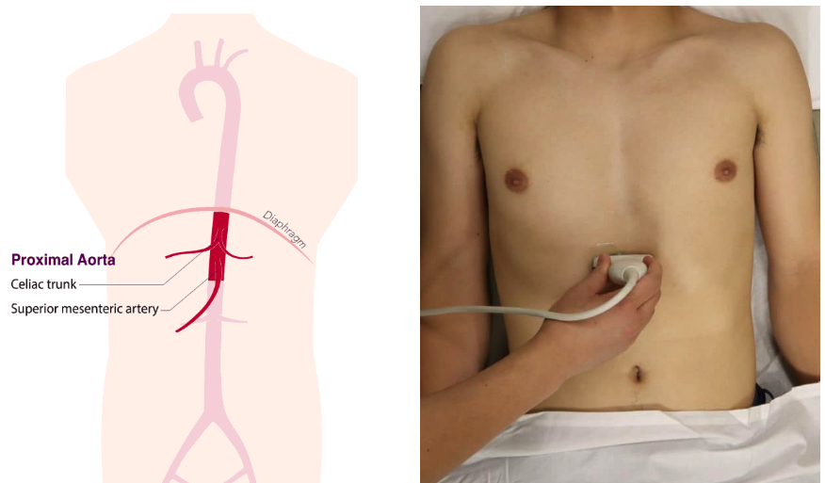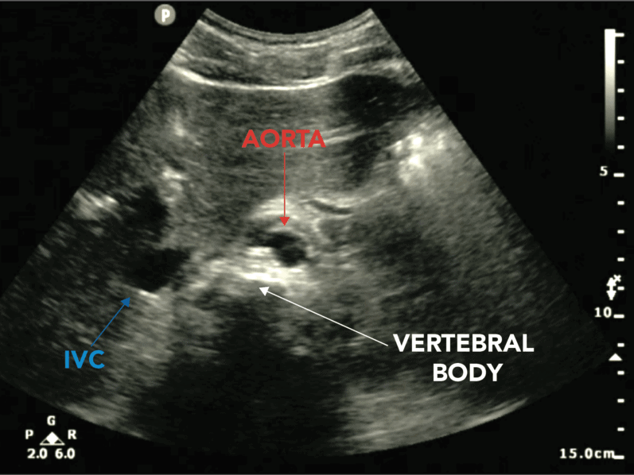

Mid aorta
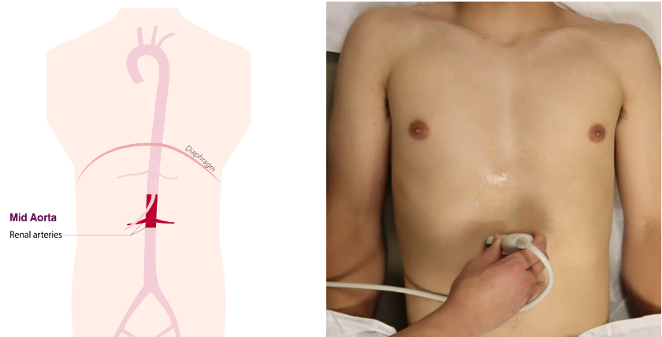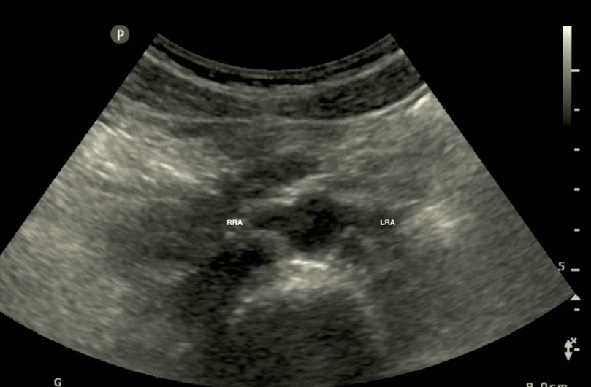

Distal aorta
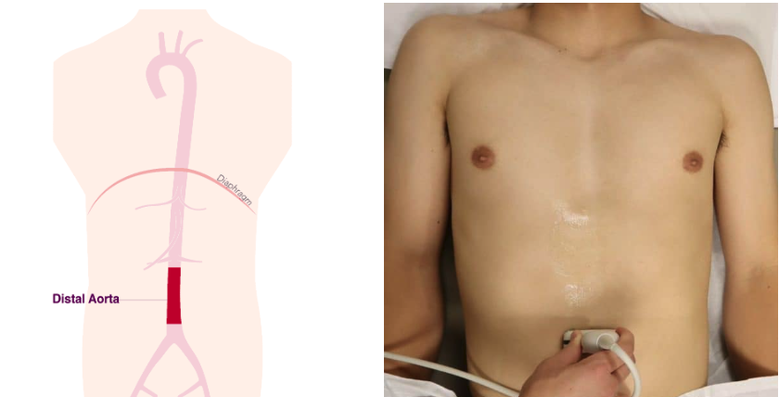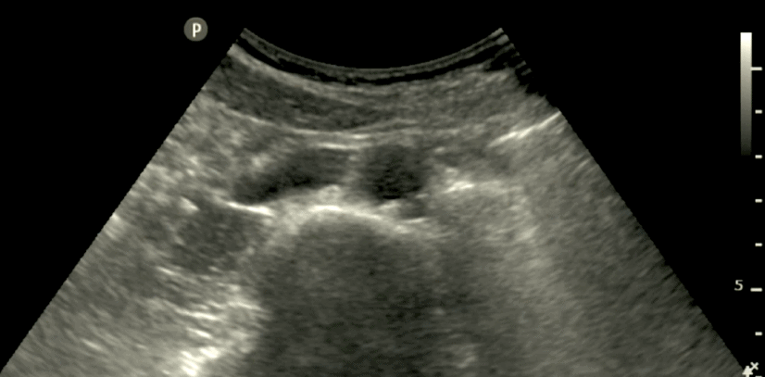

Bifurcation of the aorta
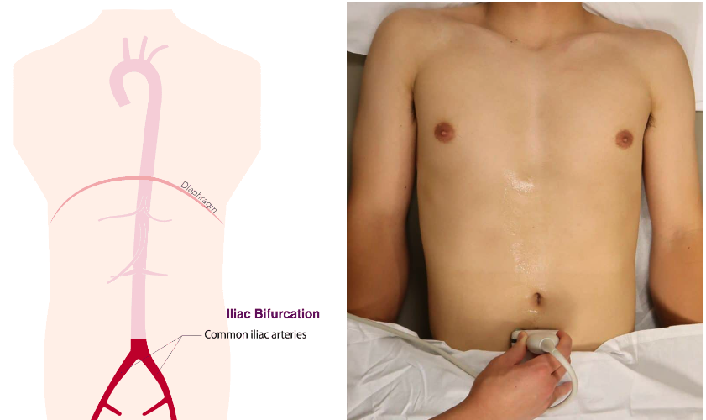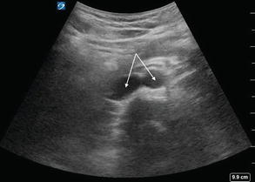

Longitudinal aorta
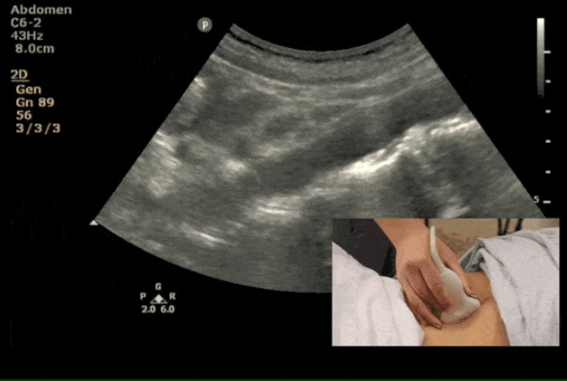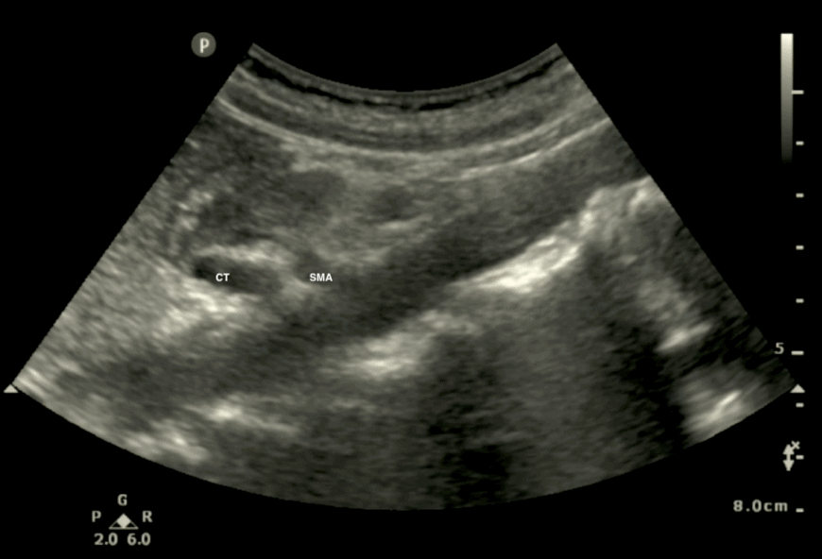

Minimal imaging sets to be recorded
- Transverse proximal abdominal aorta
- Transverse distal abdominal aorta
- Longitudinal abdominal aorta
- If aneurysm present, then transverse image and longitudinal image at the point of largest diameter
- All images should have maximal diameter measurement (outer wall to outer wall)

Logbook Requirements
- A minimum of fifteen (15) accurate examinations of the aorta must be performed.
- All examinations must be clinically indicated and at least three (3) should demonstrate an aneurysm (>3cm AP diameter).
- Adult patients only
- All logbooks must be signed off by a suitably qualified supervisor
- At least 50% of the logbook findings need comparison to further imaging

Formative/Summative assessments
Other assessments consist of 2 formative and 1 summative assessment to be completed by the Primary Clinical Supervisor. Please see the ASUM website for more information:
CCPU-AAA-Syllabus.pdf (asum.com.au)

Lung

Learning Objectives
- Describe the clinical indications for lung ultrasound
- Demonstrate the clinical context and limitations which apply to lung ultrasound and ultrasound of the chest
- Understand an approach to lung scanning including patient positioning and a standard protocol
- Understand how to optimize lung ultrasound images (probe selection, depth gain and focal zone adjustment)
- Understand the normal surface anatomy and artifacts including the chest wall, ribs and costal cartilages, visceral and parietal pleura, pleural space, lungs, diaphragm, liver, spleen, and heart.
- Describe the sonographic appearance of lung artefacts (A-lines, B-lines)
- Describe the lung US appearance of pathology (alveolar interstitial syndrome, consolidation, pulmonary oedema and pulmonary effusion)
- Attaining proficiency in ultrasound image interpretation in order to enable an appropriate differential diagnosis

Protocol
A scan that includes labelled loops (or M mode, if cine-loop not available, which would be unusual) of both sides of the thorax. Minimum records should include loops that correspond to upper/middle and lower lobes.
The course instructors advise a minimum of four (4) images per lung making a total of eight (8) to investigate the four (4) zones of the chest (see below). Where pathology of the posterior aspect of the lung is suspected, the patient should be rolled/sat forward to be scanned from the back.
In some cases the patient’s condition will not allow the full set to be obtained (eg. in an unstable patient), in which case the clinician should record whatever images are obtainable during the time available to adequately answer the clinical question without allowing the ultrasound examination to interfere with ongoing medical treatment.

4 zones of the lung
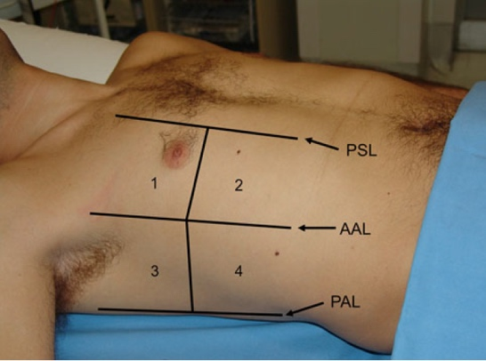

Image of zone 1 right lung
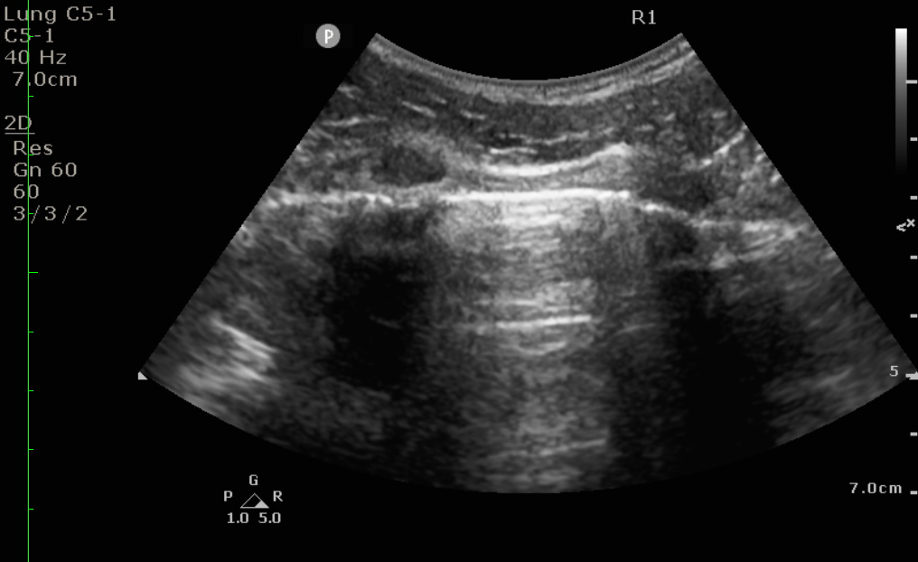

Image of zone 4 right lung
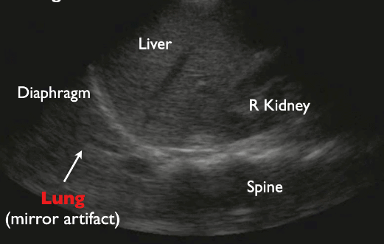

Image of zone 4 left lung
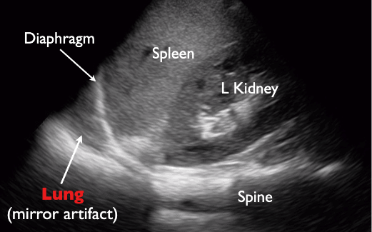

Minimal imaging sets to be recorded
- Representative cineloops of lung bilaterally. Generally anterior, lateral and posterior images are taken which should include the images of the costophrenic recesses
- Specific cineloops should recorded at sites of symptoms (eg. pain) or signs (eg. crackles)

Logbook Requirements
- A minimum of twenty-five (25) accurate examinations of the lung must be performed
- At least five (5) should demonstrate significant pathology e.g. pneumothorax, effusion, pneumonia, interstitial syndrome.
- A maximum of 50% paediatric cases (<15 years) may be included
- All of these examinations must be clinically indicated
- All logbooks must be signed off by a suitably qualified supervisor
- At least 50% of the logbook findings need comparison to further imaging

Formative/Summative assessments
Other assessments consist of 2 formative and 1 summative assessment to be completed by the Primary Clinical Supervisor. Please see the ASUM website for more information: CCPU-Lung-Syllabus.pdf (asum.com.au)

FELS (Focused Echocardiography in Life Support)

Learning Objectives
- Understand the value and limitations of FELS in the emergency setting
- Demonstrate the ability to prepare and position patients for FELS
- Understand normal heart, IVC appearance including collapsibility, pericardial fluid and chamber collapse
- Describe the sonographic signs of pericardial effusion, cardiogenic shock, massive pulmonary embolism, sepsis and hypovolemia, role of echo in cardiac arrest and its integration into ALS protocols
- Demonstrate the ability to interpret ultrasound in the setting of a shocked or arrested patient and fluid volume estimate in the shocked patient
- Demonstrate the 2-dimensional (B mode) Image acquisition:
- Imaging the heart in parasternal long, parasternal short, apical 4 chamber and subcostal views.
- Imaging IVC in longitudinal and transverse planes and assess IVC size and collapsibility
- Demonstrate image interpretation:
- Qualitative assessment of IVC, LV/RV size, LV contractility and volume status
- Recognition of cardinal ultrasound findings in shock / arrest.
- Demonstrate the ability to integrate the clinical picture and FELS findings
- Describe the role of FELS in guiding ongoing resuscitation

Protocol
This is specifically a brief, time-limited exam directed towards following the cardiac arrest/peri arrest scenario. In some cases, the patient’s condition will not allow the full set to be obtained (eg. during CPR), in which case the clinician should record whatever images are obtainable during the time available to adequately answer the clinical question without allowing the ultrasound examination to interfere with ongoing medical treatment.

During CPR usually only a single window will be used such as subcostal (or less commonly a parasternal window). In these cases, candidates must demonstrate they can obtain images without interfering with ongoing resuscitation.

The above findings are integrated with other clinical information, to consider causes of haemodynamic instability, for example hypovolemia, cardiogenic shock, tamponade, massive pulmonary embolism. Notably this examination is not comprehensive and does not evaluate valves, spectral doppler or diastolic function.

Parasternal long axis view
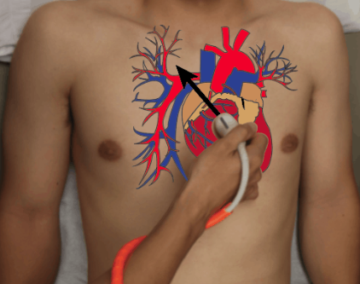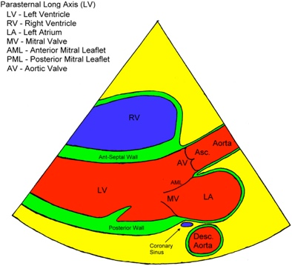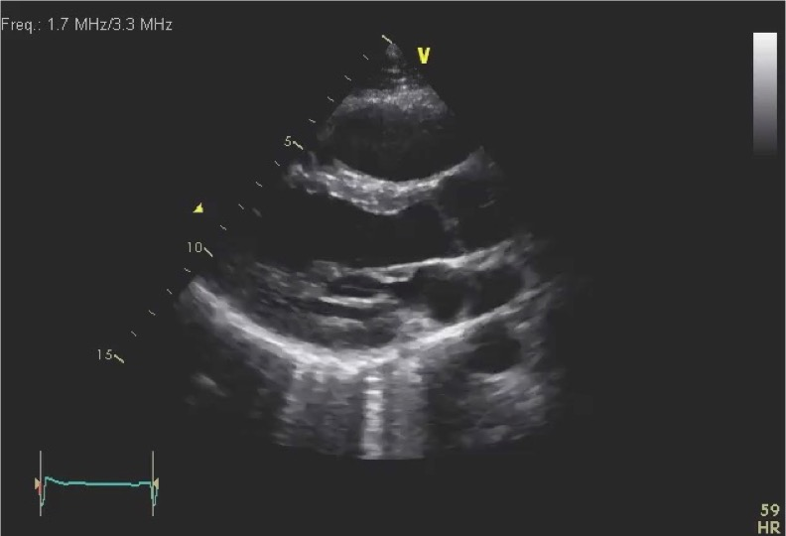
Parasternal short axis view
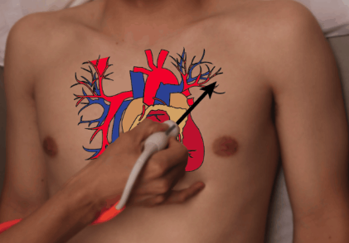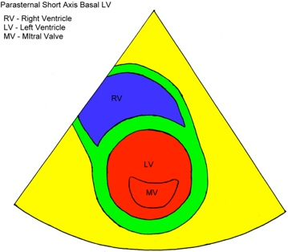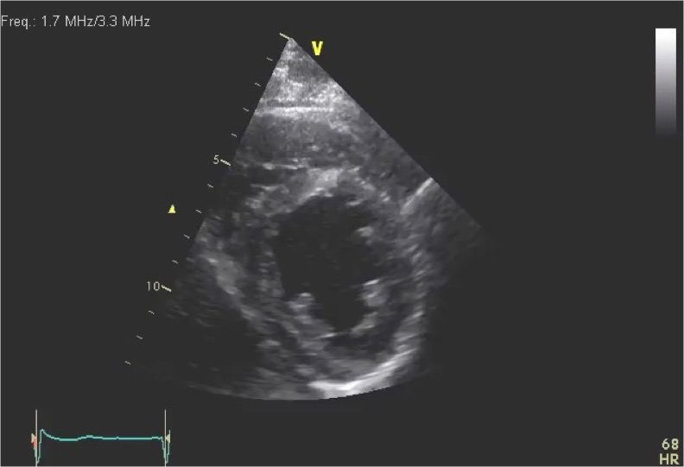

Apical 4 chamber view
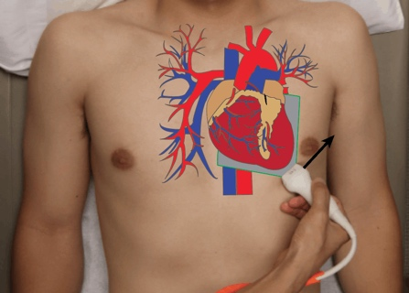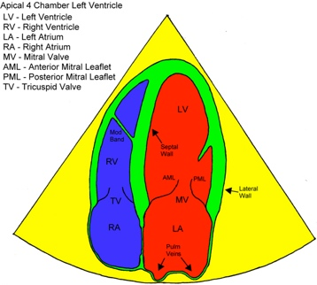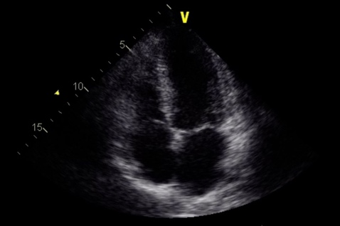

Subcostal view
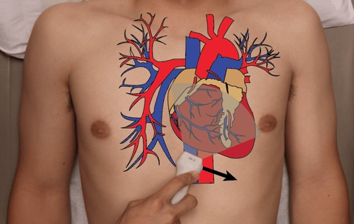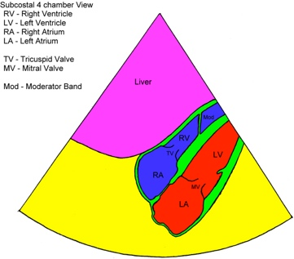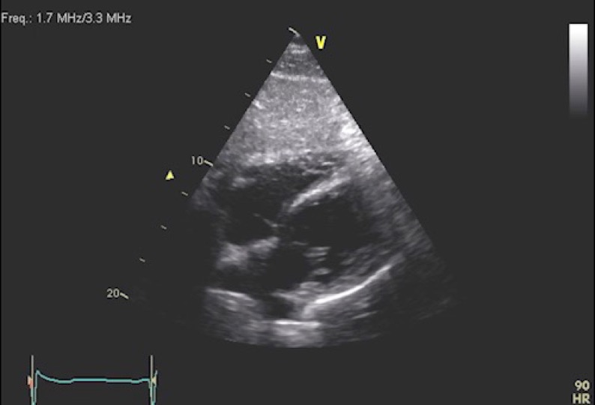

IVC view
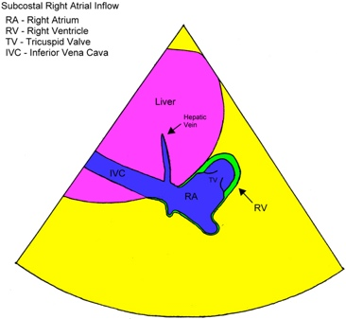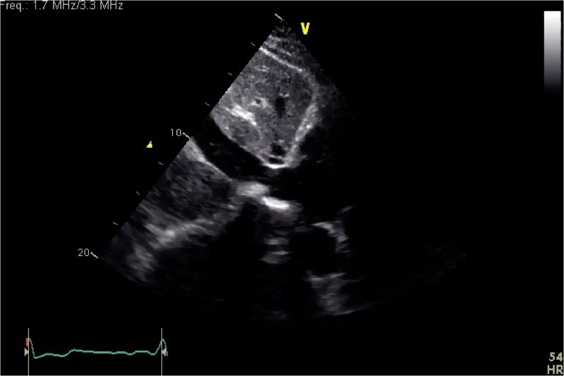

Minimal imaging sets to be recorded
- Parasternal long axis
- Parasternal short axis at midpapillary level (+/- at mitral level and apex),
- Apical 4 chamber
- Subcostal long axis (+ subcostal short axis if not obtained from parasternal view)
- IVC long axis (+ IVC short axis if longitudinal views from lateral window).
During CPR only a single window may be obtained such as a subcostal (or parasternal). In these cases, candidates must demonstrate they can obtain images without interfering with ongoing resuscitation.

Logbook Requirements
- Of the minimum fifty (50) FELS examinations (25 performed and 25 reviewed), cases must include at least 2 cases each of
- Pericardial effusion,
- Massive pulmonary embolism,
- Hypovolemia or distributive shock and
- Left ventricular failure.
- At least five (5) of the twenty-five (25) performed scans need to be in the setting of cardiac arrest or haemodynamic compromise.
- A maximum of 50% paediatric (14 years and under) may be included in the log book. Record in the column provided.
- All of these examinations must be clinically indicated
- All logbooks must be signed off by a suitably qualified supervisor
- At least 50% of the logbook findings need comparison to further imaging
- Review at least twenty-five (25) examinations (may be performed by another operator or from image bank – such as completing the online ASUM CCPU FELS image quiz.

Formative/Summative assessments
Other assessments consist of 2 formative and 1 summative assessment to be completed by the Primary Clinical Supervisor. Please see the ASUM website for more information: CCPU-Focused-Echo-in-Life-Support-Syllabus.pdf (asum.com.au)

EFAST (Extended Focused Assessment with Sonography for Trauma)

Learning Objectives
- Describe the role of eFAST in trauma and non-trauma patients
- Recognise the advantages and limitations of eFAST
- Demonstrate an understanding of the appropriate anatomy, physiology and pathology
- Demonstrate effective performance and interpretation of eFAST ultrasound
- Recognise normal and abnormal findings of eFAST
- Understand the limitations of ultrasound of chest and abdomen in trauma

Protocol
The eFAST assessment involves imaging of the right and left upper quadrants, pelvis, pericardium and both lungs to assess peritoneal free fluid, pericardial fluid and pneumothorax/haemothorax. In some cases multiple images should be recorded to fully demonstrate the pathology. However in certain cases the patient’s condition will prohibit a full set of images to be obtained (unstable trauma patient), in which the candidate should only record images in a timely fashion that adequately answer the clinical question, without interfering with ongoing medical management.

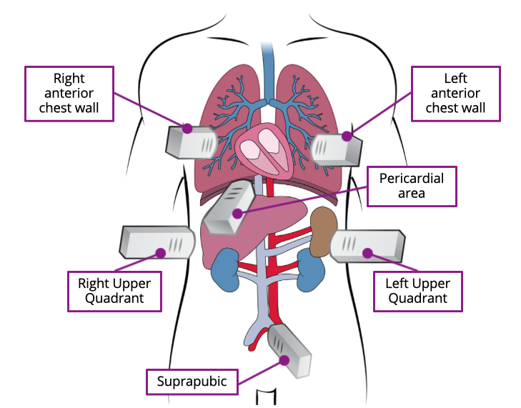

RUQ view
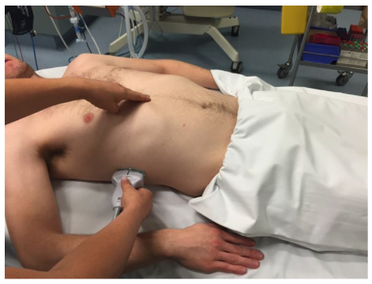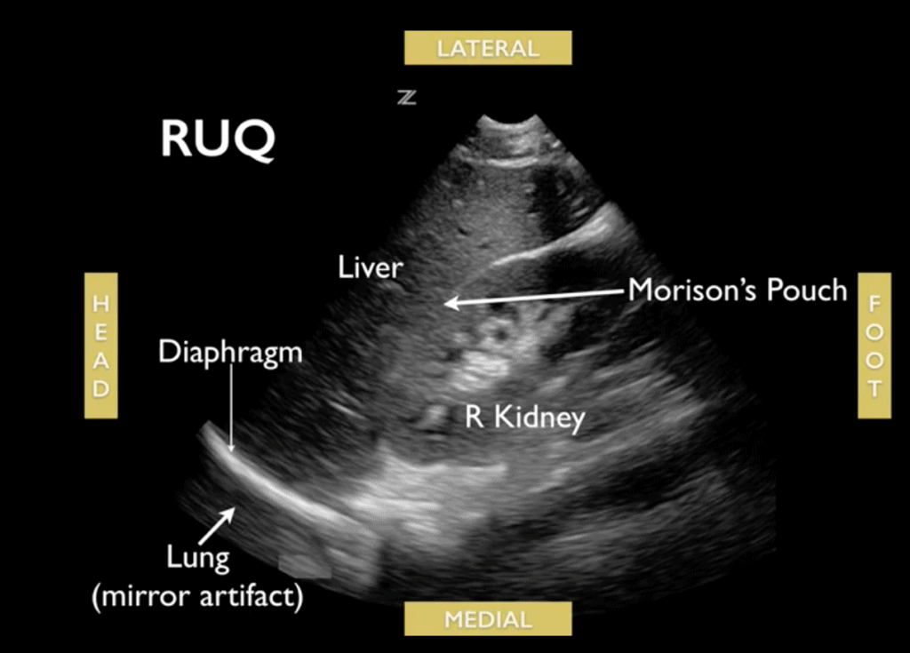

LUQ view
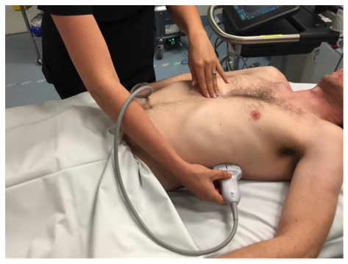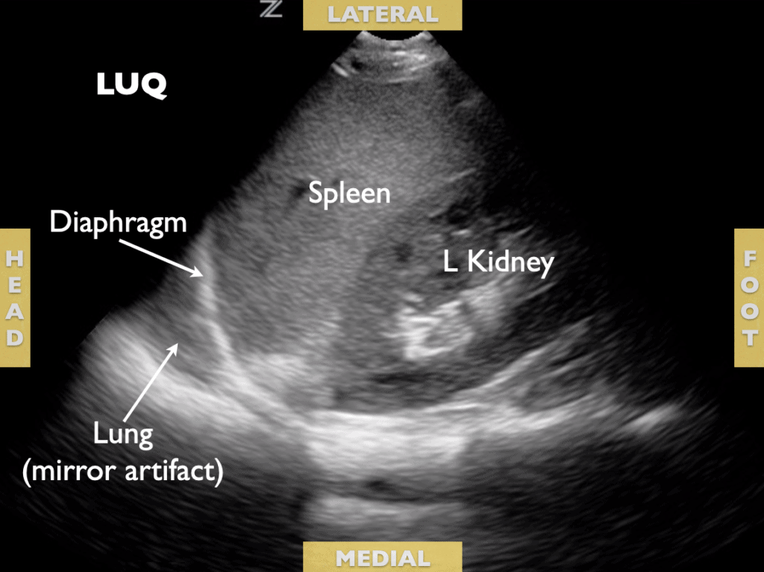

Pelvic view (longitudinal)
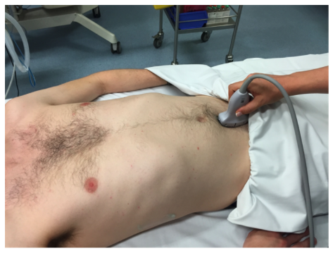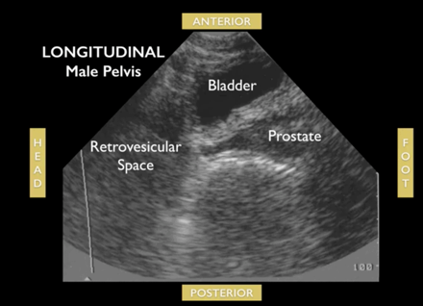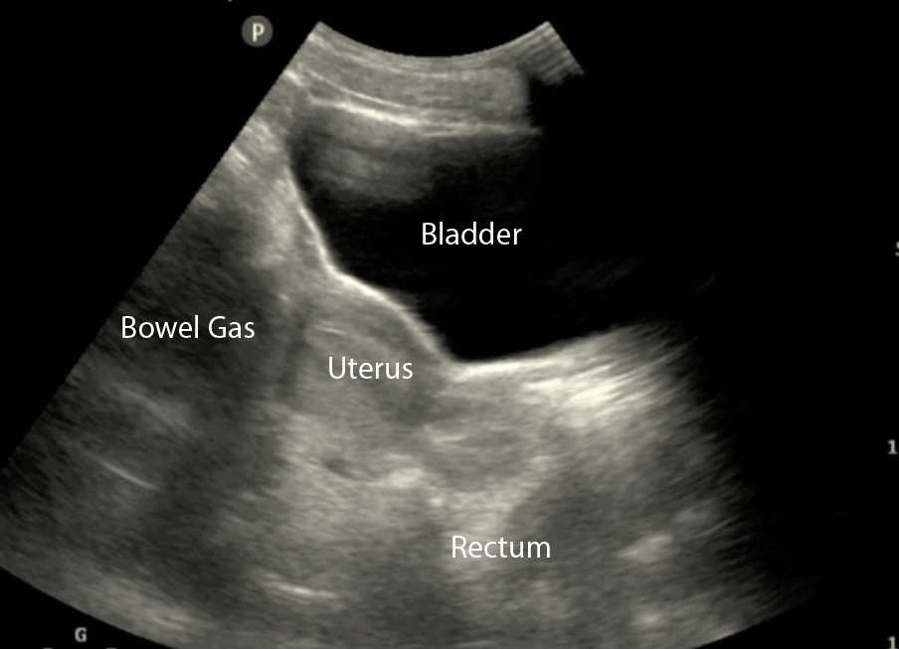

Pelvic view (transverse)
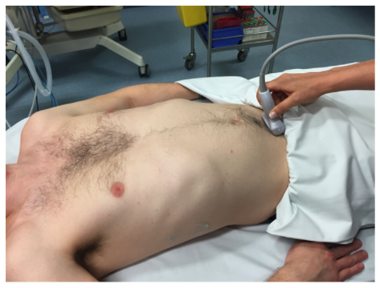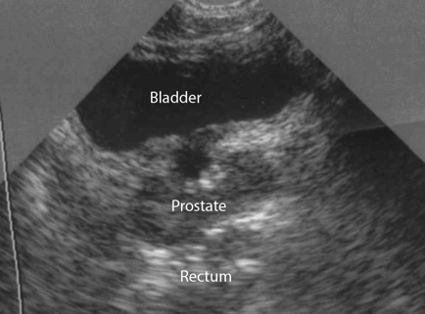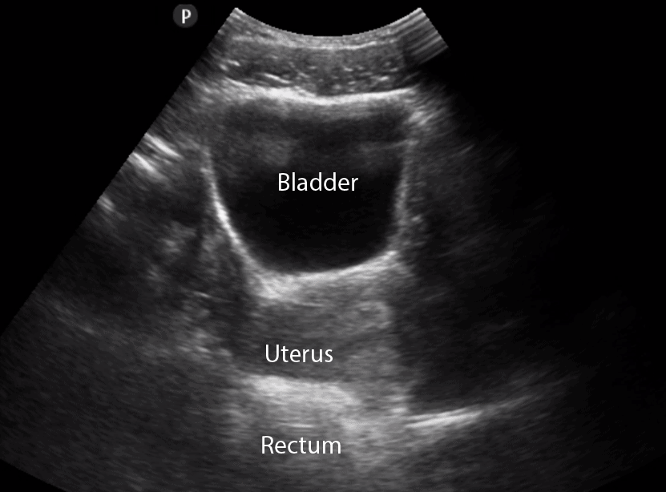

Subcostal view (cardiac)
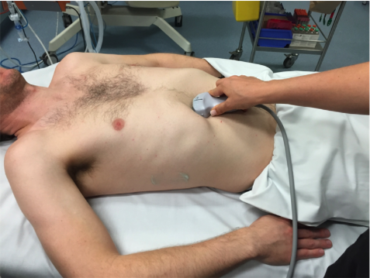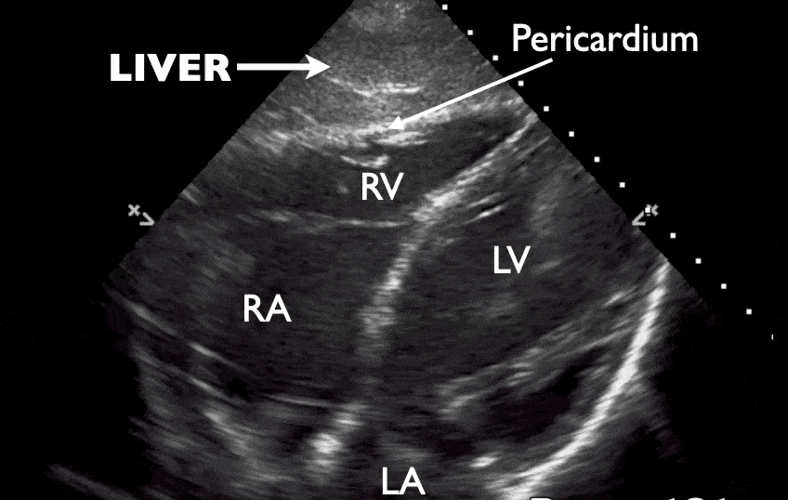

Right and left lung views
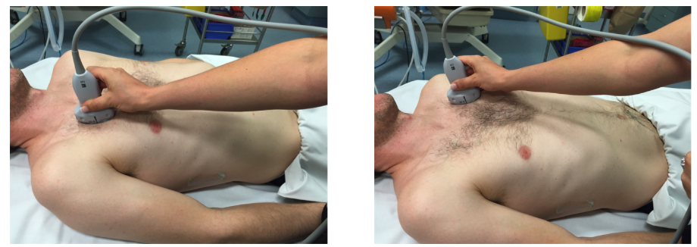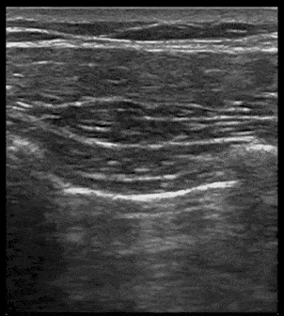

Minimal imaging sets to be recorded
- RUQ (including Morrison’s pouch, tip of liver and base of right hemithorax) still or cineloop
- LUQ (including splenorenal space, tip of spleen and base of left hemithorax) still or cineloop
- Transverse and longitudinal pelvis
- Cardiac (subcostal or other window that clearly demonstrates posterior pericardium) cineloop
- Anterior right and left lung (demonstrates presence or absence of lung sliding) cineloop or M-mode still

Logbook Requirements
- A minimum of twenty-five (25) accurate examinations must be performed.
- At least five (5) should be positive for either intraperitoneal, pleural, pericardial fluid, or pneumothorax.
- A maximum of 50% paediatric (14 years and under) may be included in the log book. Record in the column provided.
- All of these examinations must be clinically indicated
- All logbooks must be signed off by a suitably qualified supervisor
- At least 50% of the logbook findings need comparison to further imaging

Formative/Summative assessments
Assessment consists of 2 formative and 1 summative assessment to be completed by the Primary Clinical Supervisor. Please see ASUM website for more information: CCPU-E-FAST-syllabus.pdf (asum.com.au)

References/Resources

Websites:
ACEM Ultrasound Course
https://elearning.acem.org.au/login/index.php
For pre-reading including Introduction to ED POCUS, AAA, EFAST, Foundation Physics, Extended Physics, Foundation Thoracic/Lung, Extended Thoracic/Lung, Foundation FELS – Anatomy and Views, Extended FELS Anatomy and Views, Extended FELS Pathology and Clinical Integration

ASUM
www.asum.com.au/education/ccpu-course
For more course information about the Certificate in Clinician Performed Ultrasound including the syllabus for CCPU Units

POCUS 101
www.pocus101.com
For step by step tutorials for scanning AAA, eFAST, FELS and Lung

The POCUS Atlas
www.thepocusatlas.com
A collection of rare and well captured ultrasound images for use as educational material. Also includes a section on critical analysis of the literature supporting the use of ultrasound

Core Ultrasound
www.coreultrasound.com
Free online videos from Jailyn Avila including links to ‘5 Min Sono’ and ultrasound courses.

Ultrasound G.E.L Podcast – Gathering Evidence from the Literature
www.ultrasoundgel.org
Free podcast for learning about the recent literature in the field of point-of-care ultrasound

Books
Introduction to Bedside Ultrasound – Volumes 1 & 2
By Matt Dawson & Mike Malin
Free online textbook on POCUS available on iTunes/iBooks and on ‘Google’ search

Ma and Mateer’s Emergency Ultrasound (4th edition)
By O. John Ma, James R. Mateer, Robert F. Reardon, Donald V. Byars, Barry J. Knapp, Andrew P. Laudenbach

Pocket Atlas of Emergency Ultrasound (2nd edition)
By Robert F. Reardon, Andrea Rowland-Fisher & O. John Ma

Point of Care Ultrasound (2nd edition)
By Nilam J. Soni, Robert Arntfield & Pierre Kory

Emergency Point of Care Ultrasound (2nd edition)
Edited by James A. Connolly, Anthony J. Dean, Beatrice Hoffmann & Robert D. Jarman

NOTES:

